FEATURE ENGINEERING

Create a one-hour-ahead forecasting dataset, with Patumahoe O₃ as the initial target.
The most important distinction is between:
- Information available before the forecast is issued.
- Information observed during or after the hour being predicted.
The code below uses only previous measurements as predictors. It also keeps site identities explicit: Patumahoe contains O₃, NO₂, and NOx; Queen Street contains NO₂ and the available meteorological measurements. Queen Street weather must not silently be presented as Patumahoe weather.

1. Recommended feature groups
Group | Features | Treatment
Time | Hour, day, month, season, day of week, weekend, day of year | Derived from the forecast timestamp
Cyclical time | Hour sine/cosine, annual sine/cosine, weekday sine/cosine | Represents repeating cycles
Pollutant history | Previous O₃, NOx, NO₂ at 1, 2, 3, 6, 12, 24 and 48 hours | Uses historical values only
Historical summaries | Previous 3-, 6- and 24-hour means; 24-hour standard deviation | Shift before calculating rolling statistics
Meteorology | Previous temperature, RH, wind speed and wind-direction components | Queen Street measurements remain labelled QUS
Wind | Sine/cosine of direction | Avoids treating 359° and 1° as far apart
Solar radiation | Previous measured radiation, if supplied | Not present in the current files; do not invent it
Traffic proxies | Weekday morning/evening peak-period indicators | Calendar proxies, not traffic counts
Emissions-related proxies | Previous measured NOx and NO₂ | Ambient concentration proxies, not emissions inventories
Availability | Missing predictor values | Imputation fitted on training data only
Solar position or daylight information is not equivalent to measured solar radiation: actual surface radiation also depends on atmospheric and cloud conditions. The current code therefore does not create a fake radiation column from hour or temperature.

2. Modelling design used in the code
The default configuration is:
text
Target: Patumahoe hourly O3
Forecast horizon: one hour ahead
Primary predictors: previous Patumahoe pollutants + calendar features
Optional experiment: add previous Queen Street measurements
Cross-site predictors are disabled by default. Enable them only after confirming that both datasets use compatible timestamp conventions.
The code also saves a separate Queen Street feature table, so the meteorological features are created even when they are excluded from the primary Patumahoe model.
For evaluation, use chronological training, validation, and test periods—not a random split. Time-ordered evaluation avoids training on future observations and evaluating on the past.

3. Complete self-contained Kaggle code

These describe the hour being forecast, so they are known in advance.
It also creates cyclical encodings:
hoursin=sin⁡(2πh24)\mathrm{hour}_{sin} = \sin\left(\frac{2\pi h}{24}\right)hoursin​=sin(242πh​)
hourcos=cos⁡(2πh24)\mathrm{hour}_{cos} = \cos\left(\frac{2\pi h}{24}\right)hourcos​=cos(242πh​)
This represents 23:00 and 00:00 as adjacent positions in a cycle rather than numerically distant values.
Seasons are one-hot encoded rather than assigned arbitrary numbers such as summer = 1 and winter = 3.
Raw calendar descriptors are retained in the exported feature tables, while the modelling example uses the encoded alter natives.

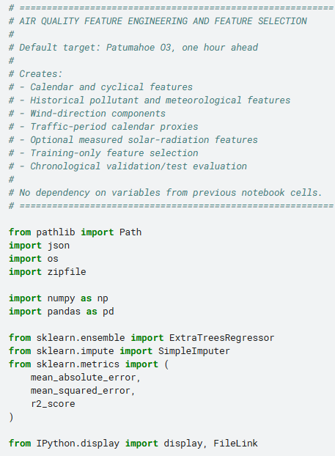

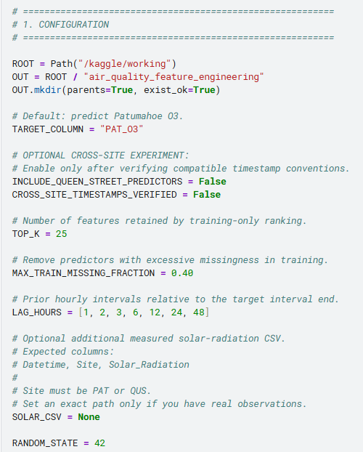

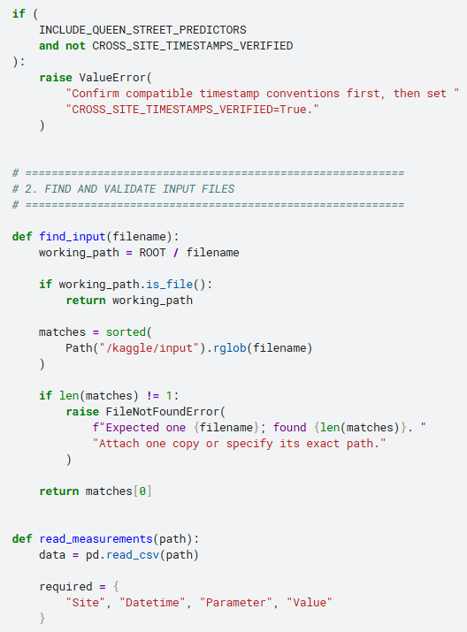

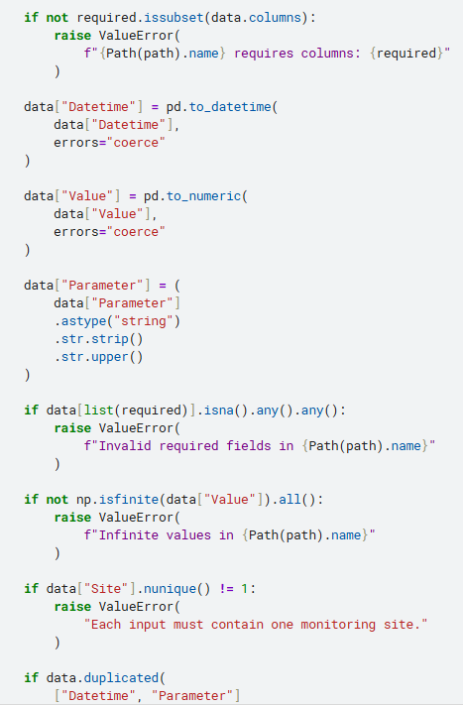

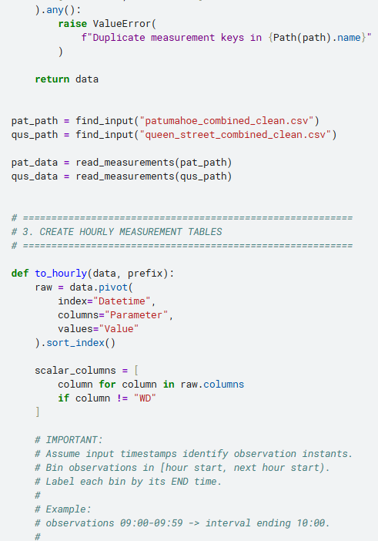

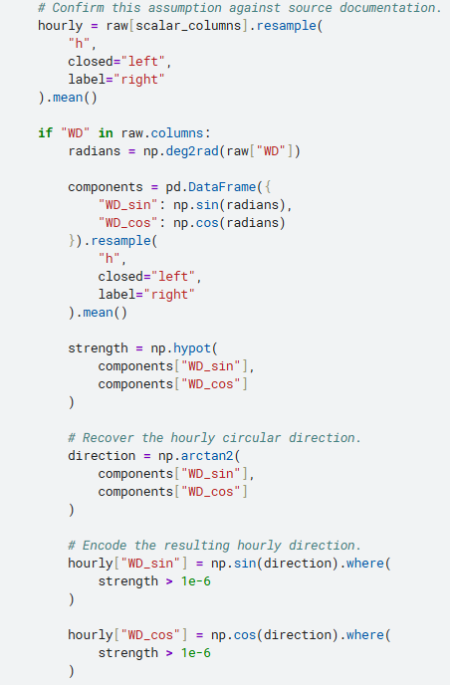

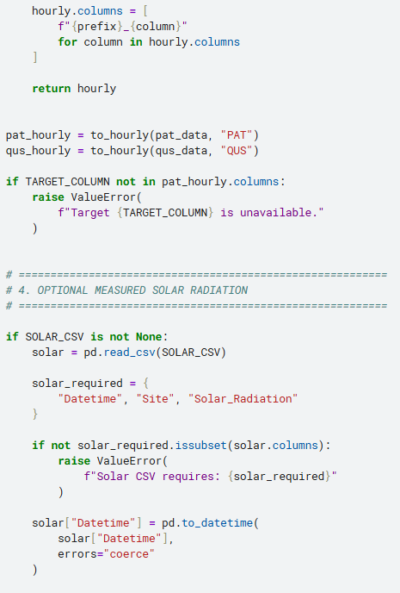

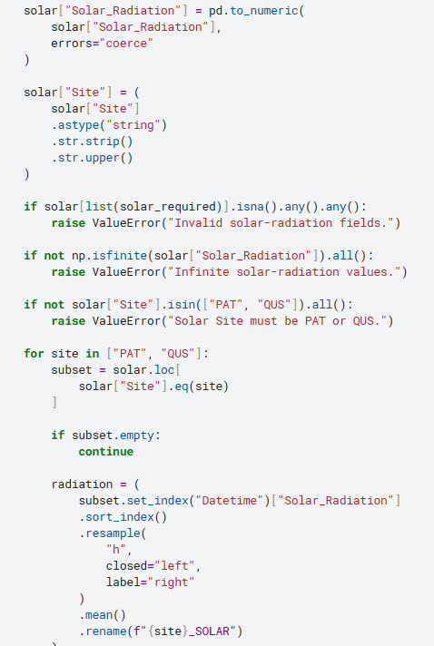

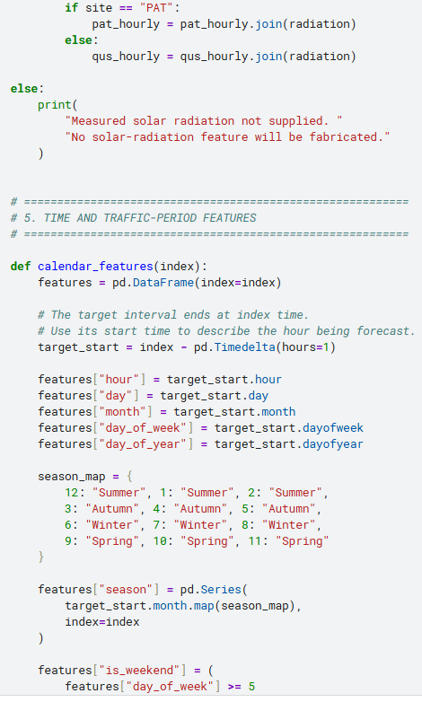

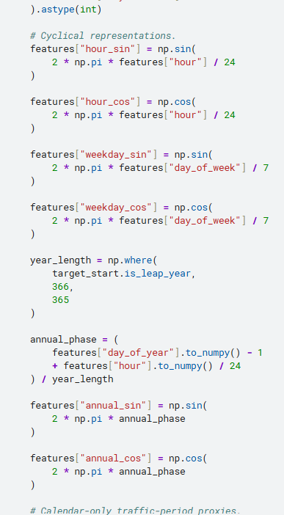

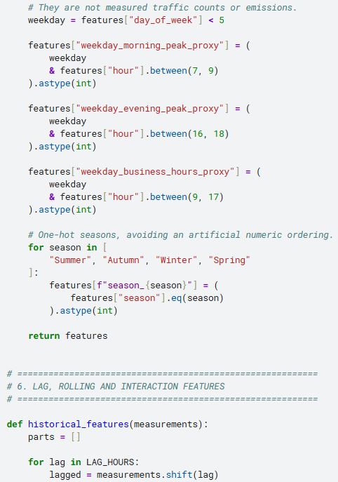

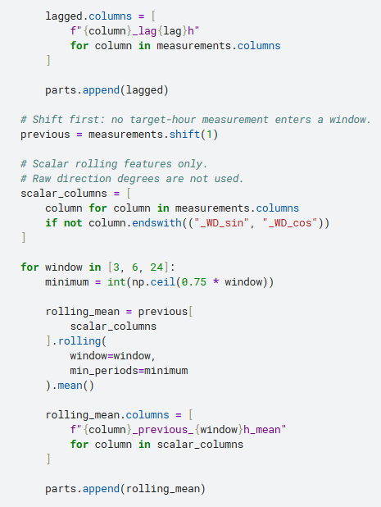

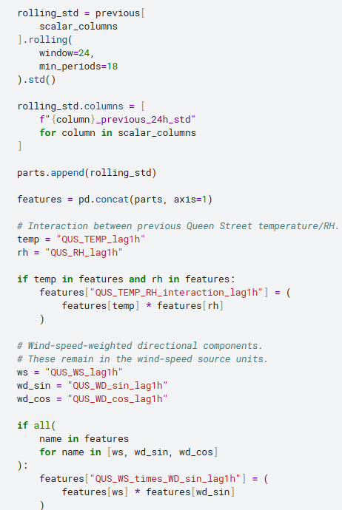

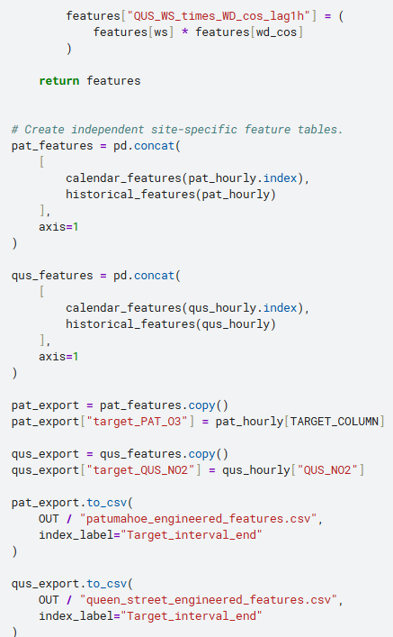

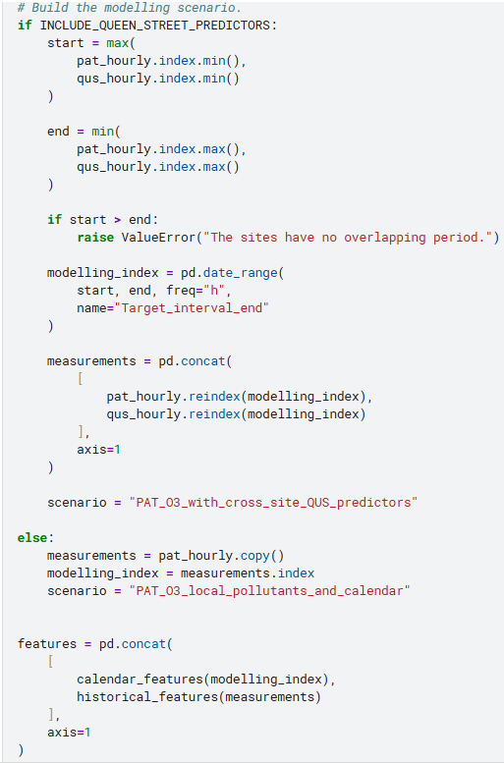

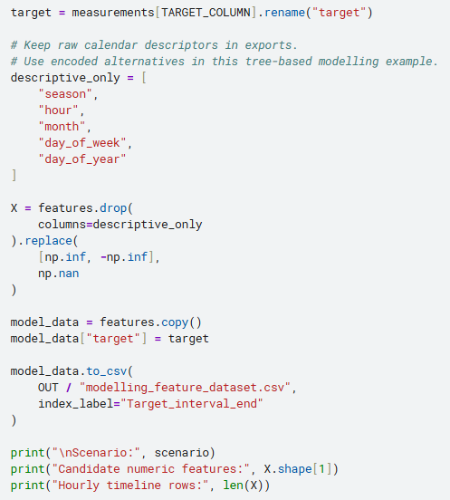

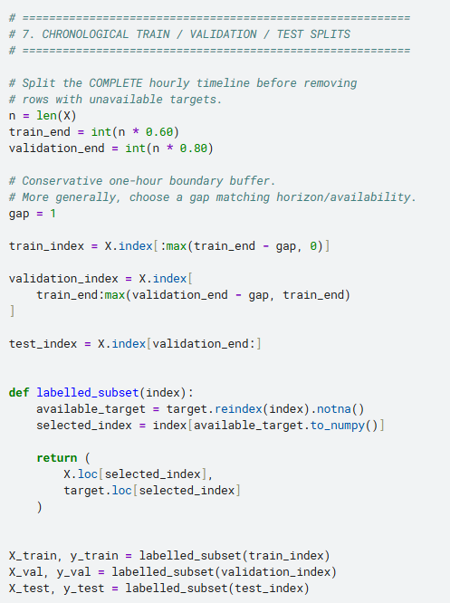

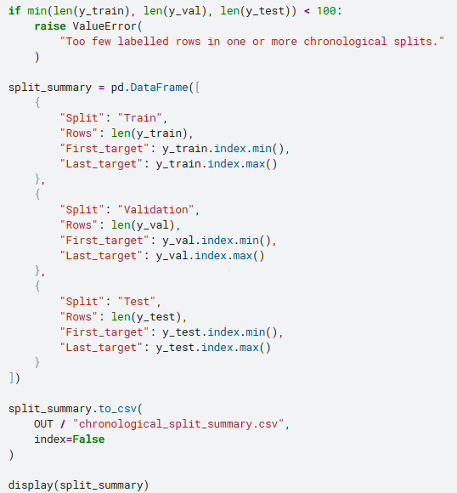

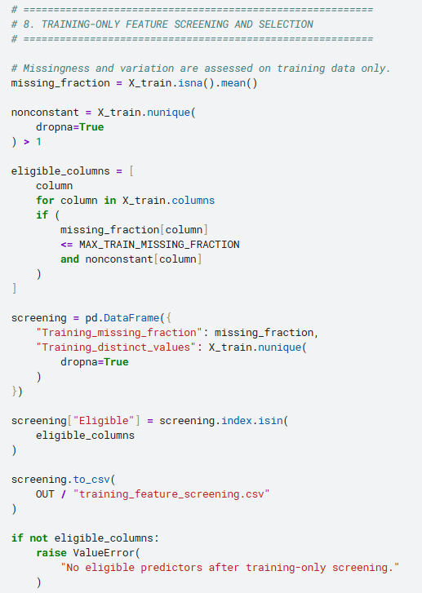

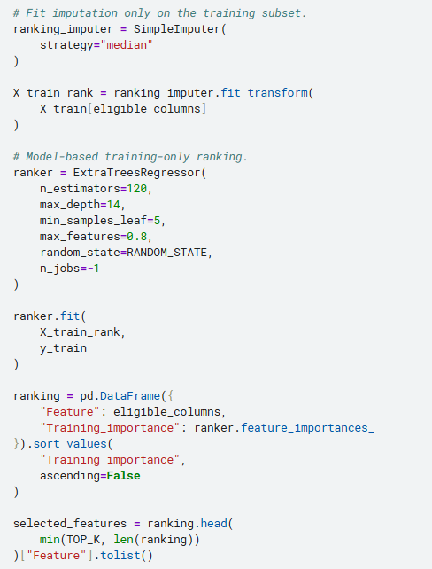

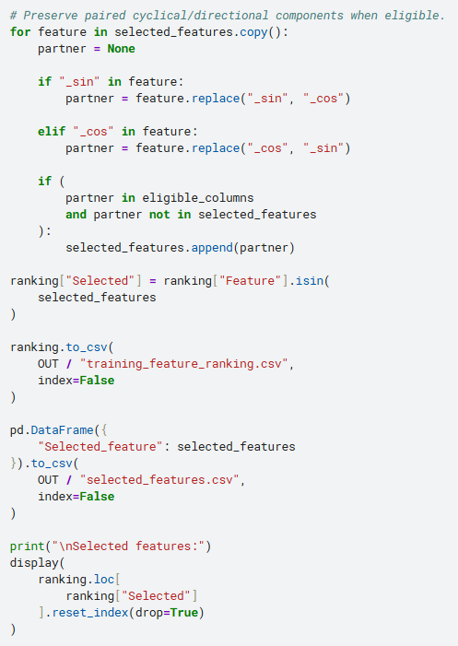

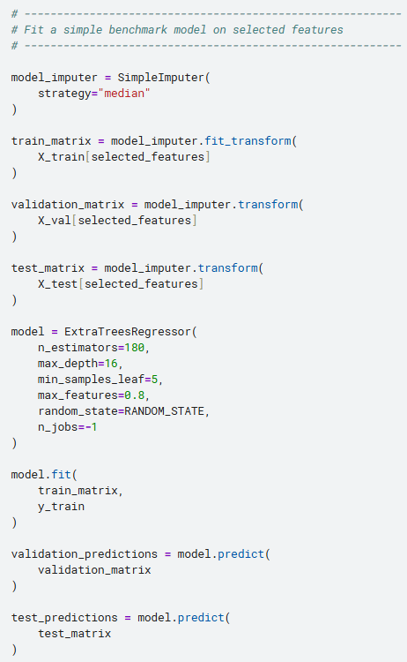

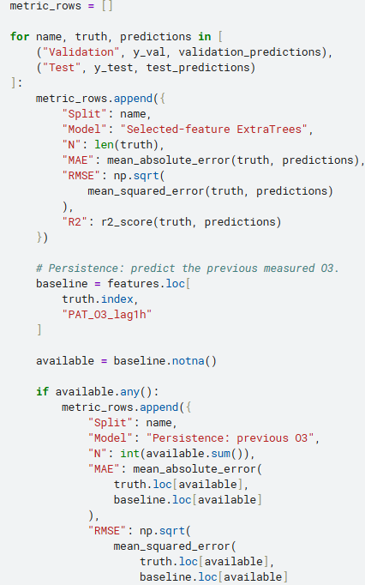

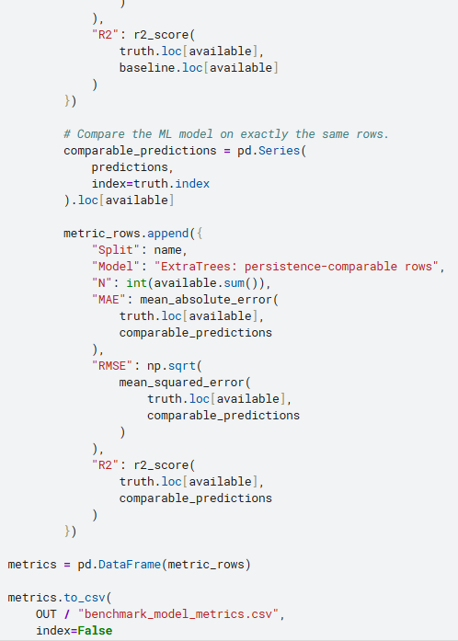

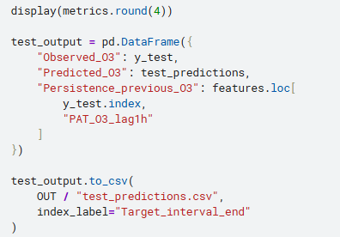

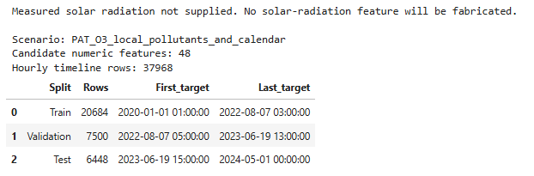

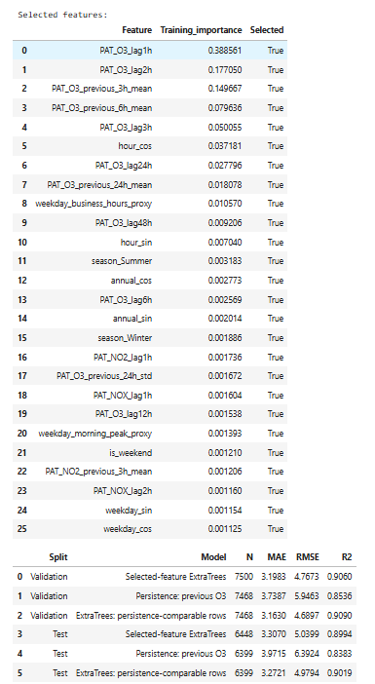

4. Explanation of the engineered features

A. Time-based features
The code creates:
text
hour
day
month
season
day_of_week
day_of_year
is_weekend
These describe the hour being forecast, so they are known in advance.
It also creates cyclical encodings:
hoursin=sin⁡(2πh24)\mathrm{hour}_{sin} = \sin\left(\frac{2\pi h}{24}\right)hoursin​=sin(242πh​)
hourcos=cos⁡(2πh24)\mathrm{hour}_{cos} = \cos\left(\frac{2\pi h}{24}\right)hourcos​=cos(242πh​)
This represents 23:00 and 00:00 as adjacent positions in a cycle rather than numerically distant values.
Seasons are one-hot encoded rather than assigned arbitrary numbers such as summer = 1 and winter = 3.
Raw calendar descriptors are retained in the exported feature tables, while the modelling example uses the encoded alternatives.

B. Lag features
Examples include:
text
PAT_O3_lag1h
PAT_O3_lag24h
PAT_NOX_lag1h
PAT_NOX_lag6h
PAT_NO2_lag24h

QUS_TEMP_lag1h
QUS_RH_lag3h
QUS_WS_lag6h
QUS_WD_sin_lag1h
QUS_WD_cos_lag1h
For a target interval ending at time ttt:
O3_lag1h(t)=O3(t−1)\mathrm{O3\_lag1h}(t)=\mathrm{O3}(t-1)O3_lag1h(t)=O3(t−1)
The code first builds a complete hourly timeline. Consequently, a one-row shift means one hour, not “the previous available measurement regardless of how long ago it occurred.”
No backward filling or future-value interpolation is used.

C. Rolling summaries
Examples include:
text
PAT_O3_previous_3h_mean
PAT_O3_previous_24h_mean
PAT_NOX_previous_6h_mean
QUS_TEMP_previous_24h_mean
QUS_WS_previous_24h_std
The ordering is important:
python
measurements.shift(1).rolling(...)
Shifting first prevents the target interval’s measurement from entering its own predictor.
The 24-hour mean requires at least 18 historical hourly observations. Missingness beyond that produces a missing feature, rather than an apparently complete average based on very few hours.

D. Meteorological features
The Queen Street feature table contains lagged:
- Temperature.
- Relative humidity.
- Wind speed.
- Wind-direction sine and cosine.
- Historical averages and variability.
- Temperature–humidity interaction.
- Wind-speed-weighted directional components.
Their QUS_ prefix is retained throughout.
These are available for Queen Street NO₂ modelling. For Patumahoe O₃, they are experimental cross-site predictors—not local Patumahoe meteorology.

E. Solar radiation
The current cleaned files do not provide measured solar radiation, so the script leaves it absent.
If you obtain real measurements, set:
python
SOLAR_CSV = "/kaggle/input/your-dataset/solar_radiation.csv"
The expected structure is:
text
Datetime,Site,Solar_Radiation
2021-01-01 12:00:00,PAT,...
2021-01-01 13:00:00,PAT,...
The script then creates historical features such as:
text
PAT_SOLAR_lag1h
PAT_SOLAR_previous_6h_mean
Verify the site, units, timezone, measurement interval, and quality controls before integration.

F. Traffic and emissions proxies
The script creates:
text
weekday_morning_peak_proxy
weekday_evening_peak_proxy
weekday_business_hours_proxy
is_weekend
These indicate periods when traffic-related activity might differ. They do not measure vehicle numbers, congestion, or emissions.
Previous measured NOx and NO₂ can also serve as emissions-related predictive indicators, but ambient concentrations are influenced by dispersion and chemistry as well as emissions.
For stronger features, obtain observed traffic counts, heavy-vehicle proportions, congestion measures, or an emissions inventory. Do not label the calendar indicators as actual traffic data.

5. How relevant features are selected
The code selects predictors without examining test outcomes.

Stage 1: Availability screening
A predictor is excluded if:
- More than 40% of its training values are missing.
- It has no variation in the training period.
The 40% threshold is configurable. A feature excluded here is not necessarily scientifically irrelevant; it may simply lack adequate historical coverage.
This is particularly important for RH, which starts later than the other Queen Street variables.

Stage 2: Training-only ranking
An ExtraTrees model ranks eligible predictors using training observations only.
The top 25 are retained, along with eligible paired sine/cosine features when needed.
This is an initial model-based screening approach—not proof that the selected variables are causally important. Correlated lag features can share or redistribute importance.

Stage 3: Validation and persistence comparison
The selected-feature model is compared with:
O3^(t)=O3(t−1)\widehat{\mathrm{O3}}(t)=\mathrm{O3}(t-1)O3(t)=O3(t−1)
This persistence baseline is essential: a complex model should demonstrate improvement over simply using the previous ozone observation.
The code reports a same-row comparison so that missing baseline values do not create an unfair comparison.

Stage 4: Untouched chronological test
The final period is reserved for testing.
If you repeatedly change features or parameters after inspecting test performance, it is no longer an untouched test set. Use the validation period for development, then evaluate the final specification once on the test period.
For a more rigorous next stage, use expanding-window cross-validation, fitting screening, imputation, and selection independently within every training fold.scikit-learn

6. Recommended modelling experiments
Use a small set of clearly separated experiments rather than assuming every engineered feature helps.
Experiment | Predictors | Purpose
Persistence | Previous Patumahoe O₃ | Minimum forecasting benchmark
Calendar + ozone history | Time features and historical O₃ | Establish temporal predictability
Local pollutant model | Add historical Patumahoe NOx and NO₂ | Test additional value of nitrogen oxides
Cross-site experiment | Add historical Queen Street NO₂ and meteorology | Test whether remote measurements improve prediction
Extended meteorology | Add verified local weather and measured radiation | Test better-supported environmental predictors
For the cross-site experiment, evaluate the local-only baseline over exactly the same dates. Otherwise, differences in performance could reflect different study periods rather than better features.
Finally, verify the unusually large Queen Street wind-speed reading identified in the EDA before using wind interactions in your final model. The script preserves retained readings; it does not silently decide which measurements are erroneous.

